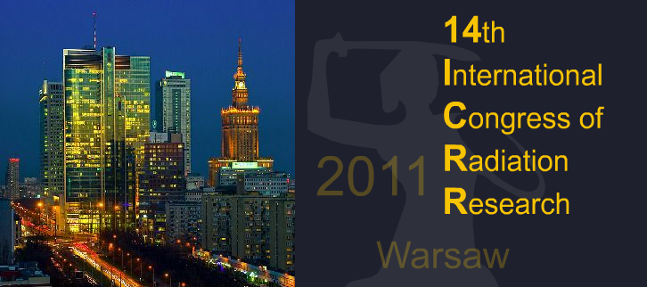
14 th International Congress of Radiation Research
Warsaw Poland
August 28 – September 1, 2011
The Palace of Culture and Science

PLEASE COMPLETE PARTICIPATION FORM (Ex –1, Ex –2)
PLEASE COMPLETE IN BLOCK LETTERS

AND RETURN IT WITH YOUR PAYMENT BEFORE 19th August 2011

Please send your filled Participation Form by e-mail: icrr2011@congressor.com.pl

or by fax: +48 22 621-31-16, 628-45-48

Please complete the Registration Forms. The deadline for registration is 19th August 2011. Exhibitors will be officially registered upon receipt of this form and the appropriate Convention dues.
A confirmation will be send either by e-mail.

VAT REGULATIONS
All prices excluding Polish VAT which is 23%, due in connection with the payment of all invoices.
All Exhibitors should provide their VAT registration number (VAT ID)

PARTICIPATION FORM Ex - 1

PARTICIPANT

PERSONAL INFORMATION:
1. Company Name:……………………………………………………………………………………………….
2. First Name………………………………………………………………………….........
Surname……………………………………………………………………………………
3. First Name…………………………………………………………………………………
Surname ……………………………………………………………………………………
4. Additional person……………………………………………………………………..…
…………………………………………………………………………………………………

Address…………………………………………………………………………………………
Street……………………………………………………………………………………………

Zip Code…………………………..City ……………………Country…………………….
Phone: ……………………………………………….….. Fax:……………………………..
E-mail:…………………………………………………………………………………………..
Contact Person:………………………………………………………………………………
VAT no:………………………………………………………………………………………….
Hereby we submit our application and order:

A. The cost of …….m² exhibition area………………………………………………………………………...PLN

B. The cost of …….m² exhibition area with build……………………..…………………………………...PLN

C. Additional orders (Ex-2)………………………………….……………………...…………...….…….…….PLN

D. Each additional person ………………. person x ……….. PLN =…….………….…………………..PLN

Total fees (items A,B,C,D) ……….…………………….……………….…………………...……..………….PLN

ABOVE PRICES ARE PRICES EXCLUDING 23% VAT

The panel inscription is as follows: (please print in block letters)

Stand area ………………………… m²
1 m²
STAND AREA ……………………….. m²
Stand drawing
(please indicate positions of electric sockets)

The advance payment of 100% of the total order value (Ex – 1) should be transferred to the account owned by “CONGRESS-OR” Congress & Tourism Bureau till 19th August 2011.

Account name: “CONGRESS-OR” Congress & Tourism Bureau
Bank name: Bank PEKAO S.A.
Branch name: O/ Warszawa
Account number: 19 1240 6218 1111 0000 4610 6520
PKO SWIFT PKOPPLPW
Title: 88-1108/ICRR/EX

Please send us copy of bank transfer.
Invoice details
Companies requiring VAT invoices are requested to complete this part fully and with due care:

………………………………………………………………………………………………………………….......(name of VAT payer)

…………………………………………………………………………………………………………..……………... (detailed address)

……………………………………………………………………………………………………………………………………….…(VAT No.)

We authorize “CONGRESS-OR” Congress & Tourism Bureau to issue the VAT invoice without signature.

……………………………………………………………………………………… …………………….
Legible signature representative of Exhibitor/Company Date

PARTICIPATION FORM Ex - 2

Additional furnishings

Additional orders | Price | Quantity | Fee total
PROJECTOR - 2000 ANSI Lumens (1 day fee) | 380 PLN
PROJECTOR -3200 ANSI Lumens (1 day fee) | 1050 PLN
PLASMA SCREEN 42” (1 day fee) | 450 PLN
LAPTOP (1 day fee) | 250 PLN
15” LCD SCREEN (1 day fee) | 230 PLN
17” LCD SCREEN (1 day fee) | 270 PLN
19” LCD SCREEN (1 day fee) | 360 PLN
ADDITIONAL ELECTRIC SOCKED (DOUBLE) 230V  (price for duration of exhibition) | 60 PLN
ADDITIONAL LIGHT POINT  (price for duration of exhibition) | 65 PLN
ADDITIONAL SHELF  (price for duration of exhibition) | 70 PLN
CHAIR  (price for duration of exhibition) | 80 PLN
CHAIR “HOCKER”  (price for duration of exhibition) | 120 PLN
TABLE “HOCKER”  (price for duration of exhibition) | 150 PLN
ADDITIONAL TABLE  (price for duration of exhibition) | 110 PLN
LOGO ON FRIEZE  (price for duration of exhibition) | 60 PLN
REFRIGERATOR  (1 day fee) | 250 PLN
LOGO ON FRIEZE  (price for duration of exhibition) | 80 PLN
CARPET /per 1 m²/  (price for duration of exhibition) | 25 PLN
FOLDING DOORS  (price for duration of exhibition) | 150 PLN
TOTAL

Above prices are net - excluding 23% VAT.

The total fees for additional orders (Ex – 2) are valued ………………………………………………… PLN

Other specific orders …………………………………………………………………………………………………………………..
…………………………………………………………………………………………………………………………………………

Lunches and coffee beaks will be available for registered ones only. Entrance will be granted only to those with an exhibitor name badge.

PAYMENT

Please indicate the exhibition code 88-1108/ICRR/EX, your name and address.
The 100% payment of the total order value (Ex – 1; Ex - 2) has been transferred to the account owned by “CONGRESS-OR” Congress & Tourism Bureau till 19th August 2011.

- by bank transfer to our account in PLN:

Account name: “CONGRESS-OR” Congress & Tourism Bureau (88-1108/ICRR/EX)
Bank name: PEKAO S.A.
Branch name: O/Warszawa
Account no: 19 1240 6218 1111 0000 4610 6520
SWIFT: PKOPPLPW
A copy of the bank transfer receipt should be attached to your Registration Form
Please make sure that your name appears on the payment.

……………………………………………………………………………………… ………………….
Legible signature representative of Exhibitor /Company Date

